Tianyi Wang

Nov. 12,2019

To Do list

Aggisnment06

**To Do List**

**Introduction**

This assignment is to create an interactive to do list that allows users to add, remove, save and read data from a file. A starter script was given, and some modification will be made to make the script work. In this assignment, define function will be mainly used.

**Class FileProcessor:**

In the starter file, two FileProcessor Classes were given and I added more functions that allows the user to save data, reload data and exit from file shown in Figure 1 and Figure 2.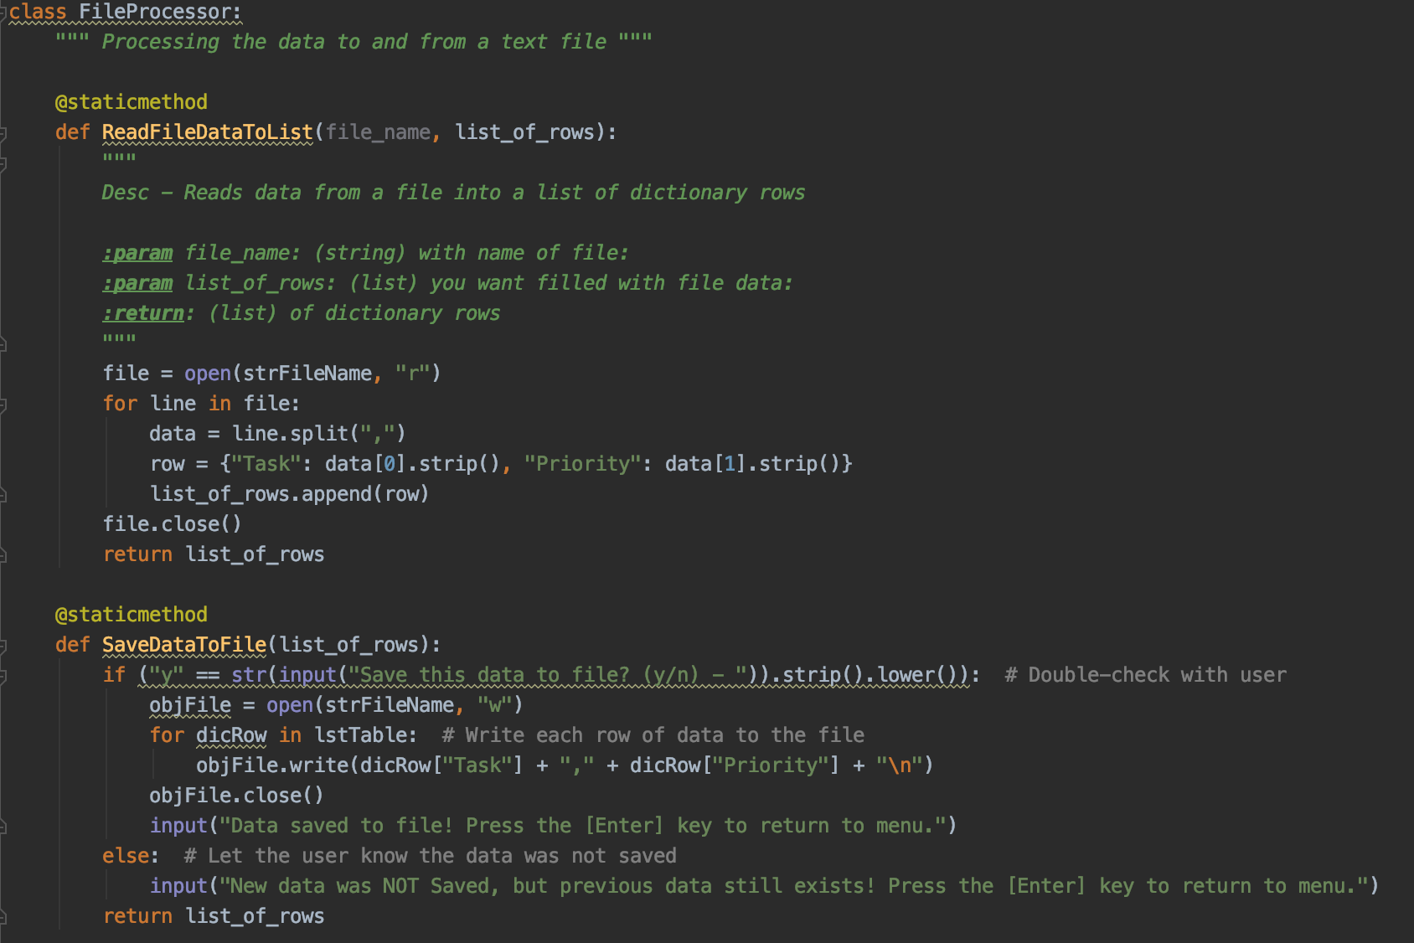

Figure 1 SaveDataToFunction defined

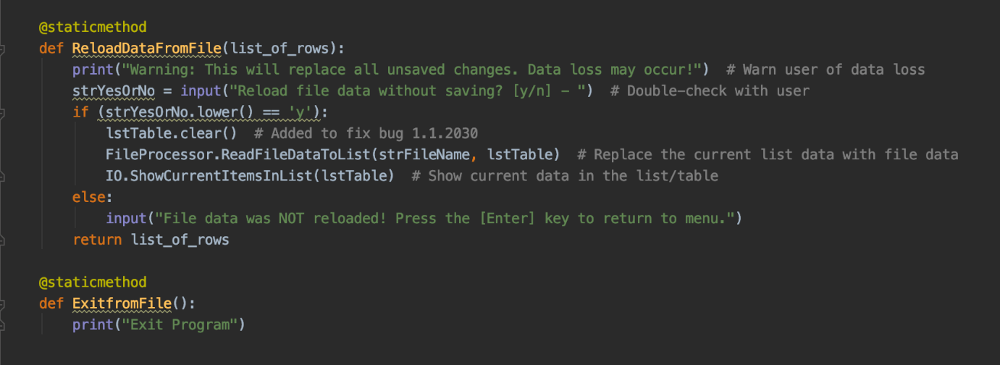

Figure 2 Reload data and exit from file function created

Since this script is a modification on top of an existing script, I basically moved the code that I need from the main body of the script into the function accordingly.

**Class IO**

Class IO is a class for perform input and output. In this function, users can input the data they want and display the data back to the user. Besides the three functions that are already existed, I added two more function which are InputNewItemToList and RemoveItemFromList(Figure 3) to perform various IO tasks according to menu.

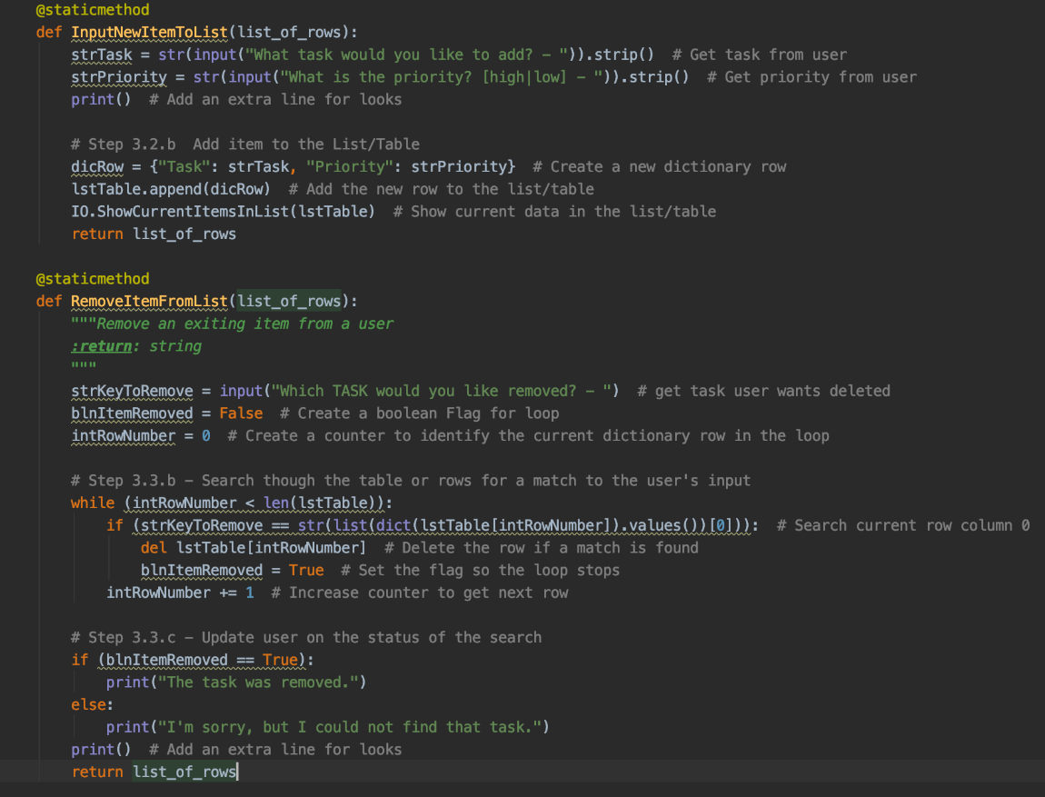

Figure 3 Two more IO functions were created

**Main body of Script**

In the main body of script, I simply deleted the original code and replaced them with the functions as needed because when I call the function, the statement in the function executes. Figure 4 and Figure 5 show how I called functions.

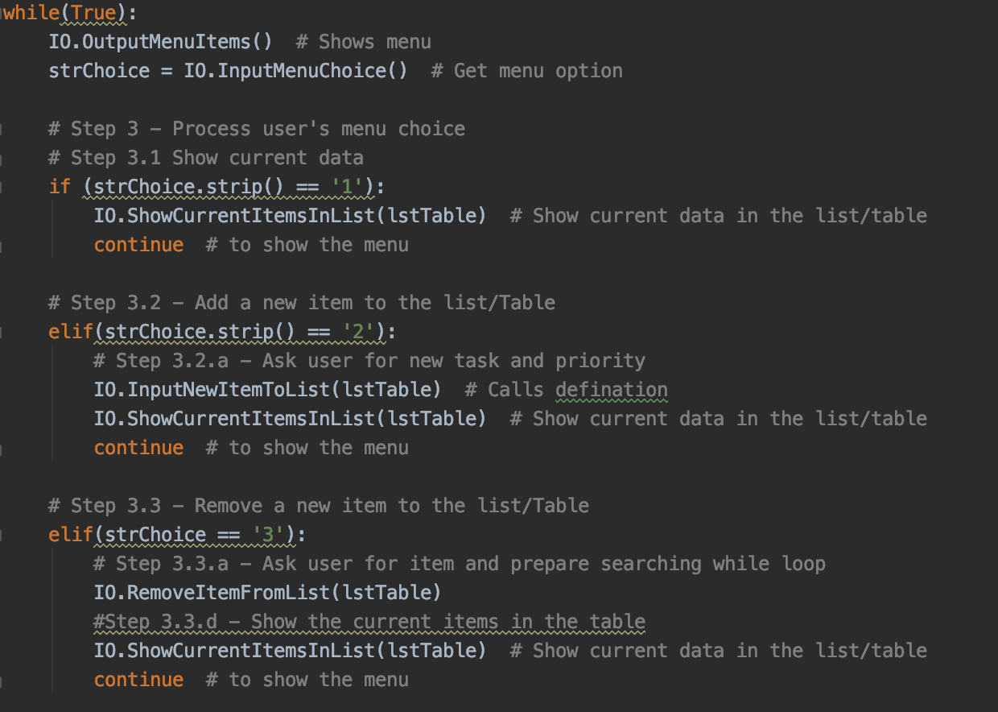

Figure Calling Functions

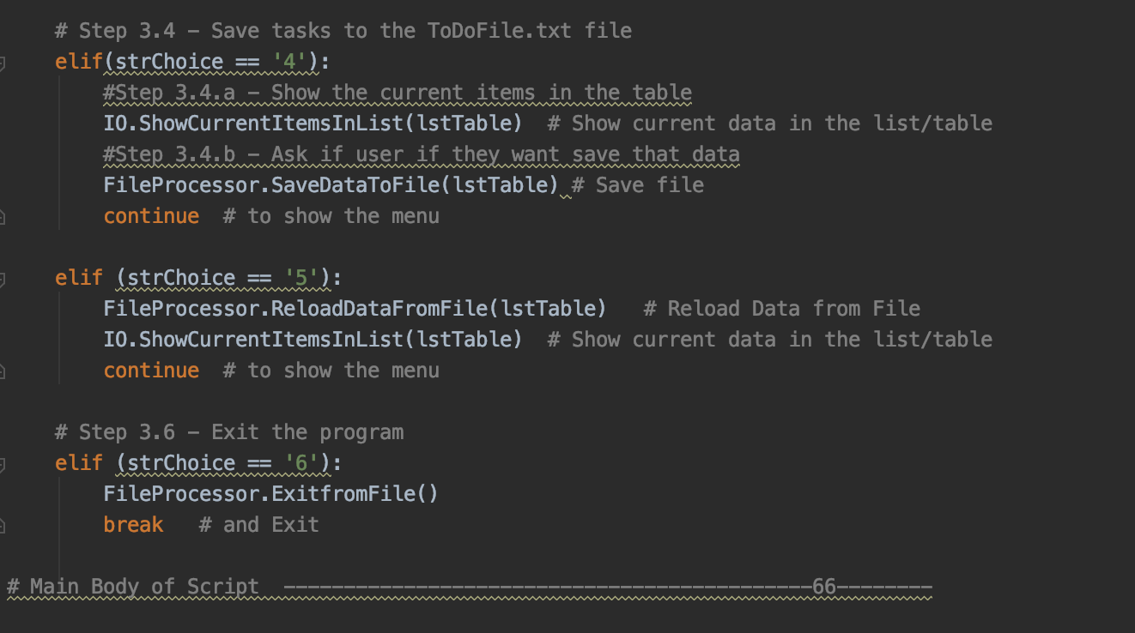

Figure Calling Functions

**Summary**

In this assignment, the most important thing is to use define functions to make script clearer and functions are very useful when they need to be used many times in the script. Define function is basically move the statements that used to be in the presentation part to functions. This makes modifying a starter script easier but makes organizing the script harder.